Document Bash Scripts
case Scripts:
- This is a menu-driven Bash script. It asks the user to choose one option, then runs a command based on that choice
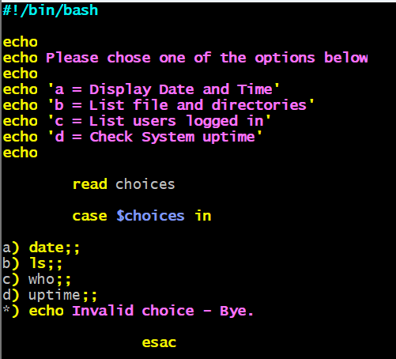
Commands Executed:
Vi CaseScripts.bash
Chmod 755 CaseScripts.bash
./CaseScripts.bash

ScreenShot:
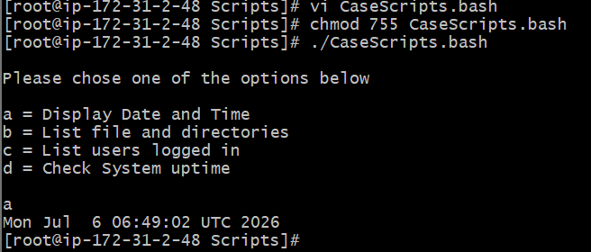

- This script will look at your current day and tell you the state of the backup
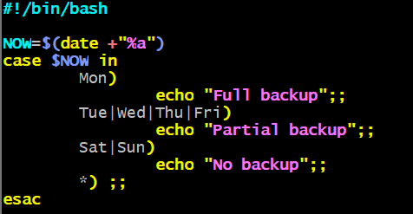

Commands Executed:
Vi CaseScripts2.bash
Chmod 755 CaseScripts2.bash
./CaseScripts2.bash

ScreenShot:
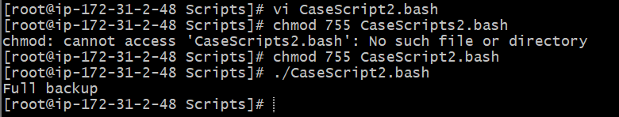

do-while Script

Script to run for a number of times
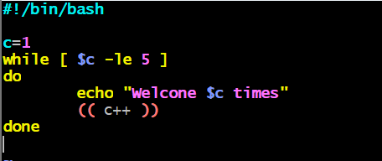

Commands Executed:
Vi DowhilScript.bash
Chmod 755 DowhilScript.bash
./DowhilScript.bash

ScreenShot:
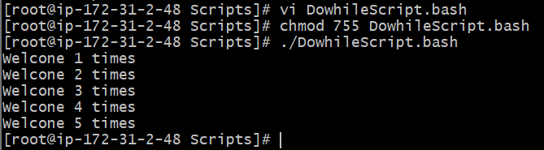

Script to run for a number of seconds
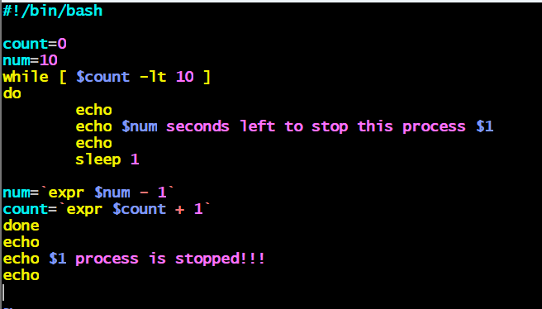

Commands Executed:
Vi DowhilScript2.bash
Chmod 755 DowhilScript2.bash
./DowhilScript2.bash

ScreenShot:
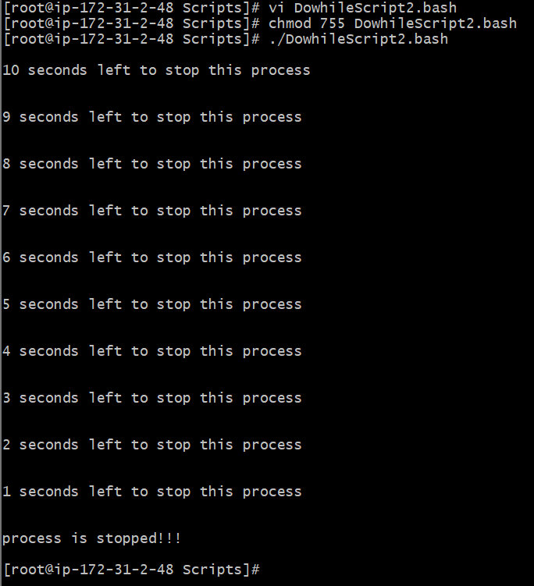
for loop Scripts:

Simple for loop output
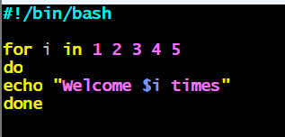

Commands Executed:
Vi ForLoopScript.bash
Chmod 755 ForLoopScript.bash
./ ForLoopScript.bash

ScreenShot:
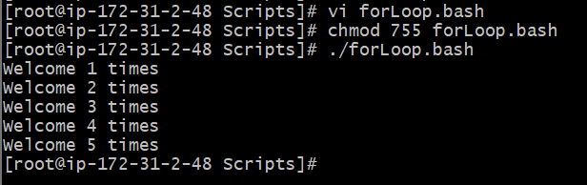

Simple for loop output
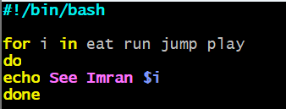

Commands Executed:
Vi ForLoopScript2.bash
Chmod 755 ForLoopScript2.bash
./ ForLoopScript2.bash

ScreenShot:
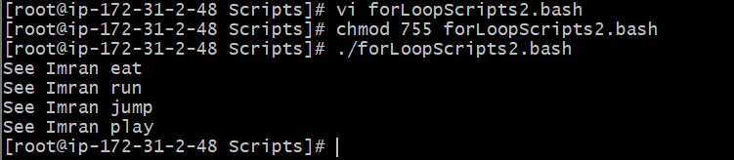

for loop to create 5 files named 1-5
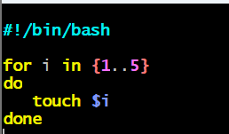

Commands Executed:
Vi ForLoopScript3.bash
Chmod 755 ForLoopScript3.bash
./ ForLoopScript3.bash
ScreenShot:
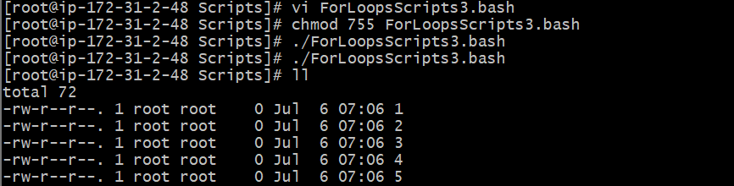

for loop to delete 5 files named 1-5
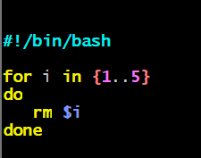

Commands Executed:
Vi ForLoopScript4.bash
Chmod 755 ForLoopScript4.bash
./ ForLoopScript4.bash
ScreenShot:
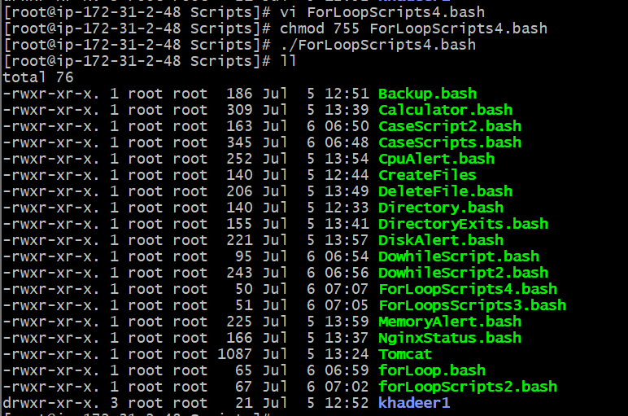

Specify days in for loop
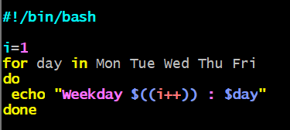
Commands Executed:
Vi ForLoopScript5.bash
Chmod 755 ForLoopScript5.bash
./ ForLoopScript5.bash
ScreenShot:
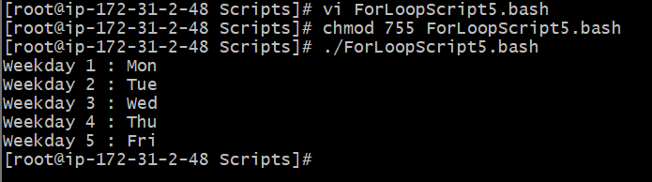

List all users one by one from /etc/passwd file
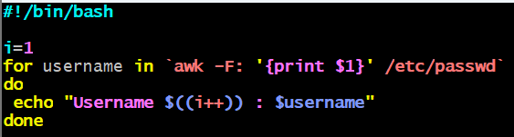
Commands Executed:
Vi ForLoopScript6.bash
Chmod 755 ForLoopScript6.bash
./ ForLoopScript6.bash
ScreenShot:
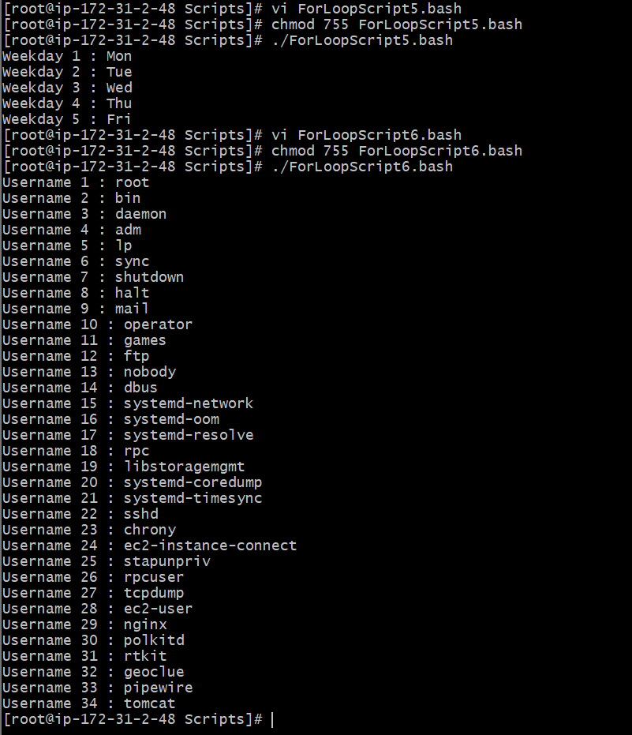


If-then Scripts:
Check the variable
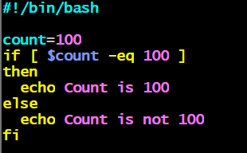
Commands Executed:
Vi IfThen.bash
Chmod 755 IfThen.bash
./IfThen.bash
ScreenShot:
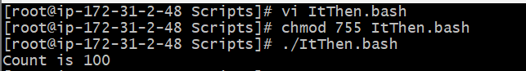

Check if a file error.txt exist
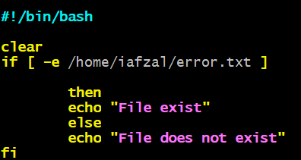
Commands Executed:
Vi IfThen2.bash
Chmod 755 IfThen2.bash
./IfThen2.bash
ScreenShot:
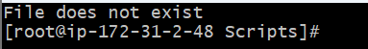

Check if a variable value is met
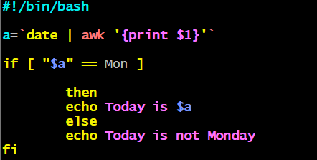
Commands Executed:
Vi IfThen3.bash
Chmod 755 IfThen3.bash
./IfThen3.bash
ScreenShot:
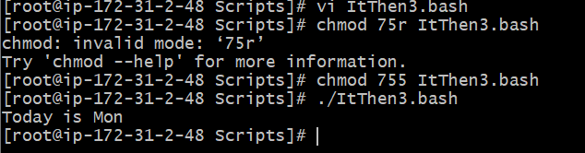

Check the response and then output
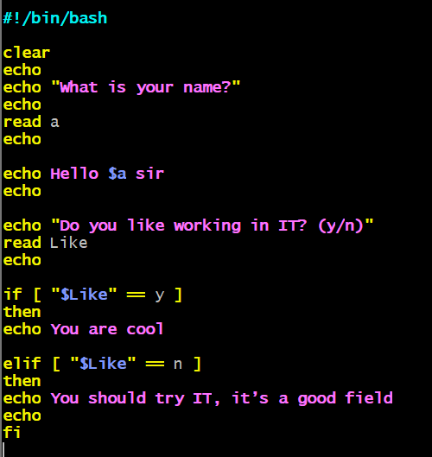

Commands Executed:
Vi IfThen4.bash
Chmod 755 IfThen4.bash
./IfThen4.bash
ScreenShot:
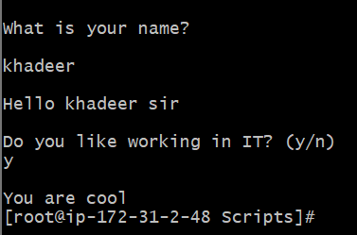

Other If statements
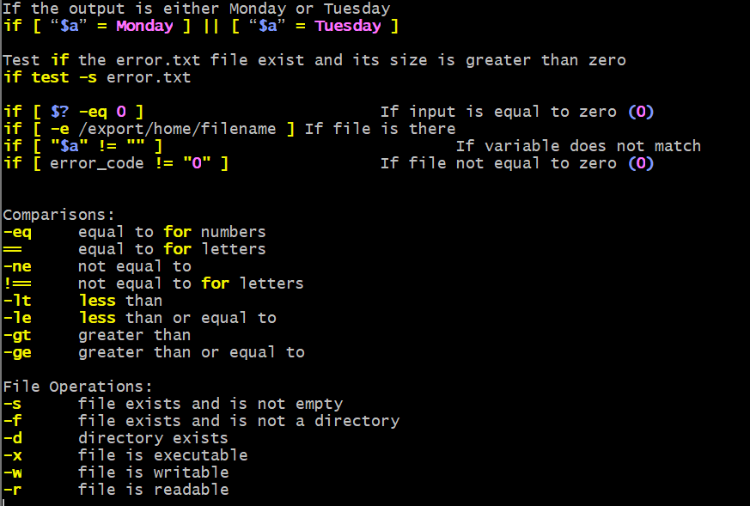
Commands Executed:
Vi IfThen5.bash
Chmod 755 IfThen5.bash
./IfThen5.bash
ScreenShot:
